--1.Calculate Total Sales Over Time:

2.Monthly Average Sales:

10. Calculate Weekly Sales Trends:

11. Exponential Moving Average (EMA) for Smoothing:

12. Identify Peaks and Valleys in Sales:

13. Anomaly Detection using Z-Score:

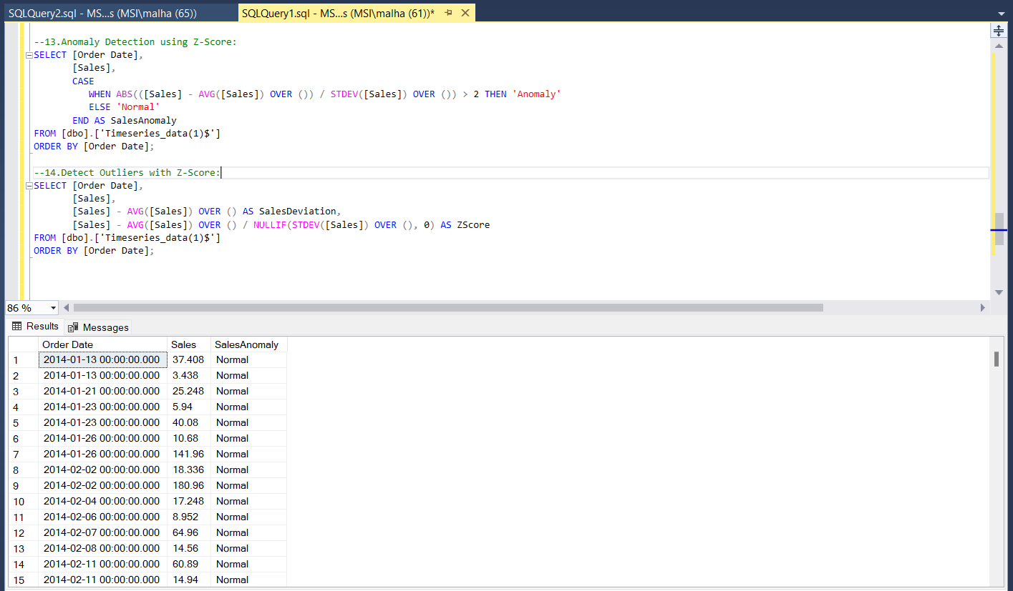

14. Detect Outliers with Z-Score:

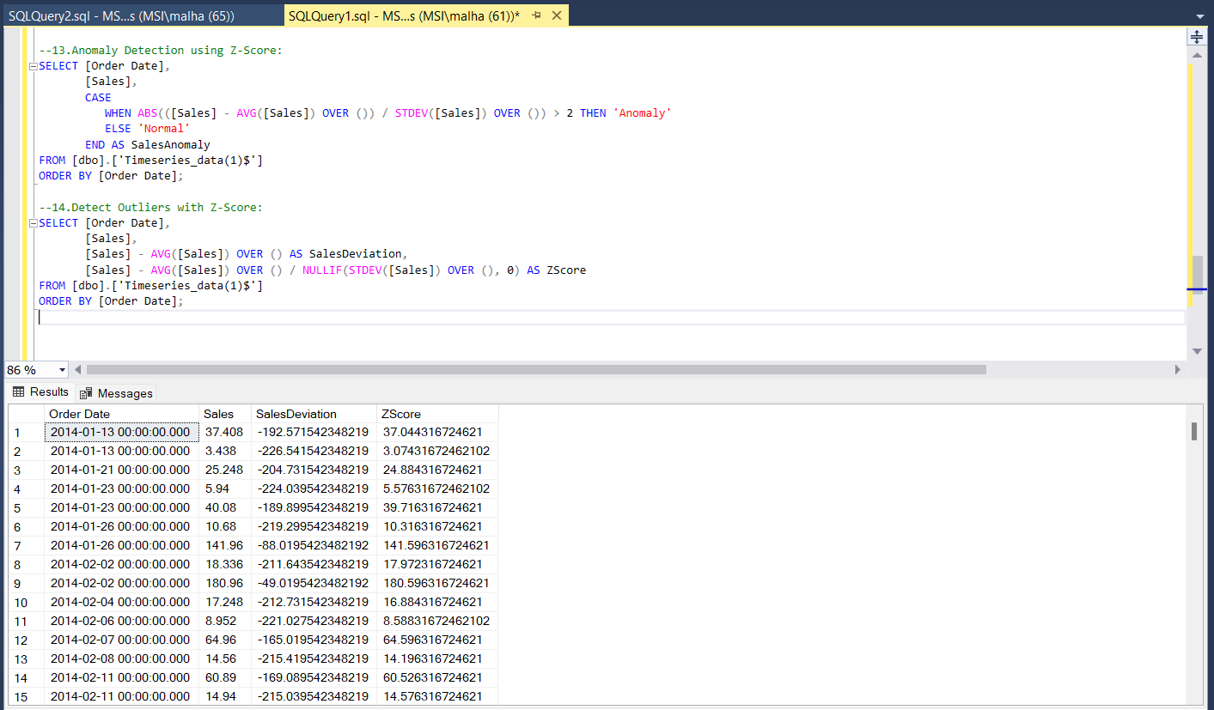

16. Calculate Seasonal Index:

